Student Worksheet 2. The “Nueva Planta” Decrees
The Nueva Planta decrees (Spanish: “Decretos de Nueva Planta”, Catalan: “Decrets de Nova Planta”) were a number of decrees signed between 1707 and 1716 by Philip V—the first Bourbon King of Spain—during and shortly after the end of the War of the Spanish Succession by the Treaty of Utrecht.
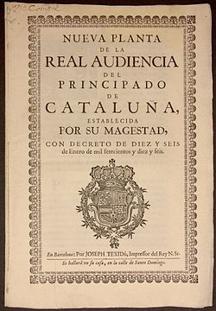
Angered by what he saw as sedition by the Aragonese and taking his native France as a model of a centralised state, King Philip V suppressed the institutions, privileges, and the ancient charters (Spanish: “fueros”, Catalan: “furs”) of the different kingdoms and principality that were formerly part of the Crown of Aragon (Aragon, Catalonia, Valencia, and the Balearic Islands). The decrees ruled that all the territories in the Crown of Aragon were to be ruled by the laws of Castile, that the 1707 defined "the most praiseworthy in all the Universe", embedding these regions in a new, and nearly uniformly administered, centralised Spain.
The acts abolishing the charters were promulgated in 1707 in Valencia and Aragon, in 1715 in Majorca and the other Balearic Islands (with the exception of Menorca, a possession of the Kingdom of Great Britain at the time), and finally in Catalonia on 16 January 1716.
https://commons.wikimedia.org/wiki/File:NuevaPlanta1775.pdf
The decrees effectively created a Spanish citizenship or nationality that judicially did not distinguish between Castilian and Aragonese anymore, both with respect to rights and law. They abolished internal borders customs and charters except for the Basque territory and Navarre (both territories supported Philip V during the war), giving grant to all Spaniards to trade with American colonies (not only Castilians, as before).

Read carefully this text and highlight which were the main reasons for Philip V to abolish the charters of the Crown of Aragon.
Discuss with your group:
- what were the main consequences of the Nueva Planta Decrees?
- Why did the Basque Provinces and Navarre maintain their charters?
- The new political organization of Spain was influenced by a foreign country. Which one?

