Teacher Material 4 – the relations between the development of football and the Industrial Revolution (includes questions for classroom debate)
Tip for the teacher: choose only some of the examples below, using the ones that resonate the most with your students. Are they crazy fans of Barcelona? Then focus on this team!
After the first Industrial Revolution, football spread quickly thanks to the economic power of the British Empire. It is interesting to note, however, that there was a big difference between football in Great Britain and football in the rest of Europe and the world: football in Britain was practised by individuals from all social classes, but in all other countries it was spread and picked up only by members of the upper classes. Football spread throughout Europe thanks to football players, workers, students, military personnel, industrialists and businessmen.
It is important to remember that before 1850 the industrial revolution was limited to Britain and a few areas in Western Europe and North America. Between 1850 and 1870, coal mining, iron foundries, textile factories, steam engines, and railroads (all important factors in Britain’s Industrial Revolution) spread further in Western and Central Europe, and North America. Outside of these areas, no industrial revolution occurred until after the 1870s. Starting from the 1880s, the railway industry became predominant in Eastern Europe, and this can be seen in many teams which, still today, are called “Lokomotiv”.
When we talk about football and migration in the period 1815 – 1914, we talk about:
a) The migration of individuals who founded the first football clubs in Europe
b) Football clubs established as a result of mass migrations caused by the industrial revolution.

a) The migration of individuals who founded the first football clubs in Europe
Throughout Europe, many football clubs were established in this period by migrant workers, members of the upper classes, and students. For example:
- In Spain, the first clubs were founded by British miners or railroad workers;
- In Italy, the first clubs were founded by British, Italian, and Swiss members of the upper classes and industrialists (still today, many clubs in Italy are controlled by members of the Italian upper classes);
- In France, the first teams were founded by Scots and Englishmen living in Paris, or by Parisian students;
- We find what is likely the first non-British football club in Germany: the Dresden English Football Club was founded on 18 March 1874 by British workers in Dresden. In its foundation year this club had more than 70 members, most of them Englishman working in the country;
- In Switzerland, many football clubs were founded in this period by British elite students in the cities of Geneva and Constance.
It was from Switzerland than the game started spreading in Central Eastern and Southern Europe, promoted by Swiss merchants, academics, and teachers.

Some interesting people in this period are:
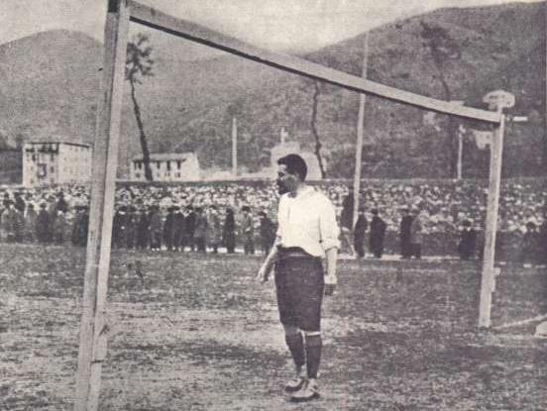
Dr. James Richardson Spensley (1867 –1915) was an English doctor, footballer, manager, scout leader and medic from Stoke Newington, London. He is considered to be one of the "Fathers of Italian football", due to his association with Genoa CFC and his contribution to how the game is played in Italy still today. During World War I, he worked in the medical field. He was injured on the battle field while tending to the wounds of an enemy out of compassion.
Source of the image: Wikimedia Commons. Author Unknown, Public Domain.

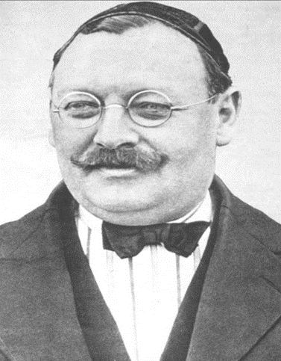
Hans Max Gamper-Haessig (1877 – 1930), known in Catalonia as Joan Gamper, was a Swiss football pioneer, versatile athlete and club president. He founded football clubs in Switzerland and Spain, most notably FC Barcelona and FC Zürich. As a youngster, Gamper was a keen cyclist and runner. Throughout his life he was a lover of all sports and, apart from football, he also played rugby, tennis and golf. In Switzerland he was highly regarded as a footballer. His first football club was Excelsior Zürich (which became FC Zürich in 1896) sporting the same colors (red and blue) as, later, FC Barcelona. In the early years of football in Switzerland, it was allowed to play for an indefinite number of teams from other cities as a guest player in friendly games – Gamper is known to have played among others two games for FC Winterthur and FC Basel. FC Barcelona is an example of clubs founded by a rich individual, but as a result of mass migration (and as such it covers both our categories)
Source of the image: Wikimedia Commons, Author Unknown, Public Domain.

b) Football clubs established as a result of mass migrations caused by the industrial revolution.
These are football clubs established by migrant communities in new countries. They were established to give a sense of belonging, and are still existing.
This happened, for example, in Scotland, where in 1800 Glasgow was one of the largest cities in the world, and known as "the Second City of the Empire" after London. In this period the harbor grew and grew, becoming an industrial and trading center. The growth of industry resulted in the arrival of large numbers of workers from Ireland who moved to work in factories and mines in the 1830s and 1840s. Many of them were seasonal workers, employed on the construction of docks, canals and railways.
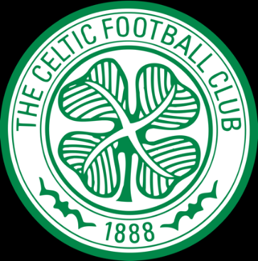
The Celtic Football Club is based in Glasgow and plays in the Scottish Premiership. The club was founded in 1887 to tackle the poverty of the immigrant Irish population in the East End of Glasgow.

Another example is Manchester. This was one of the fastest growing cities during the first Industrial Revolution, especially thanks to many workers coming from other parts of Britain. From a relatively small town in the beginning of the 19th century, Manchester had passed one million inhabitants by 1900 and had become one of the biggest cities in Europe.
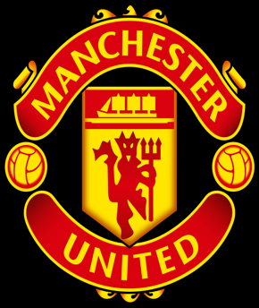
In 1878 a football club for workers of a railway company was founded in Manchester. This club, which was the meeting place for workers from all over Britain, is now known as Manchester United.

Backed by a hardworking population, Barcelona was the first Spanish city to embrace the Industrial Revolution, and was Spain’s leading industrial city for years. As a consequence, the first railway line of the entire country was established here in 1848, and the city started being known as “the Manchester of the South”
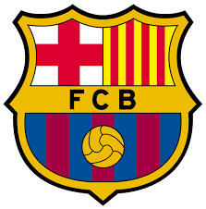
FC Barcelona was founded in 1899 by Hans Gamper, a Swiss accountant representing the interests of various French and Swiss companies. It was composed entirely of foreigners who had been prevented from joining a local gymnastics clubs. Players from the first Barcelona team came from as far as Britain, Switzerland, Germany and Austria, and the club colours of blue and red, chosen by Gamper because they were the same colours as those of his home canton’s flag, represented its initial cosmopolitan identity.

Kharkiv (Ukraine) became a major industrial centre and with it a centre of Ukrainian culture. Still today, industry plays a great role in its economy, which is specialized in industrial machineries and electronics. There are hundreds of industrial companies in the city.
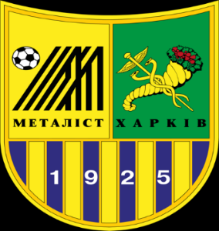
Metalist Harkiv was founded 1925 as KhPZ, in what is today Ukraine, when a local locomotive construction facility (Kharkiv Steam-locomotive Factory, today the Malyshev Factory) provided funding to its workers and allowed the use of its land to start a football club.

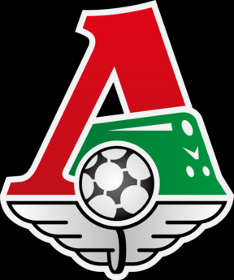
Moscow was, and still is, is a compact and highly industrial city in Russia.
Lokomotiv Moscow was founded in 1922 as part of the Lokomotiv Voluntary Sports Society, and was owned by the Soviet Ministry of Transportation through the Russian Railways.

Question for classroom discussion:
- How important was the role of industrialists in spreading football throughout Europe? Why?
- Is there any football club that was founded by an industrialist in our country?
- Do you support any special club? If yes, do you know who founded it and when?
- Who else, together with the British, is responsible for the development of football in Europe?
- Is there a football club whose name is related to industry in our country?

